# Raw Data

Total Patients considered 18, 9 Sepsis and 9 No-Sepsis. Two parameters used are HR (red) and SpO2 (green). We use leave one out for training.

UHID No Sepsis Case = {str} '3133495.0_0'

UHID Sepsis Case = {str} '3135679.0_0'



X Axis is length of stay in minutes (3 days of data)

**Questions**

* The data is for 3 days from when sepsis culture was sent.
* For all cases there seems some episodes of no-device data, how should those be handled?
* In SpO2, why there are so many sharp declines throughout the signal- checked with clinical team and this is nature of SpO2 probe.

# Data Cleaning

We did data averaging (bandpass) to generate the envelope and filter out spikes. Tried both polyfit (degree 3) and convolve operation (tried both square and guassian).

**Questions**

* Is convolution or polyfit loose any clinical insights

# Signature Analysis (every 2 hours)

1. Data of 3 days (=3*24*60) are divided into (=2*60) windows generating 36 blocks of data for each patient
2. Normalize data (0-1 scaled)



# Day Wise Charts

## Each block containing one day data (only HR)



**Questions**

* The first term is always 1. Shall we get rid of the same?

**Feedbacks from Dr. Lopa Mukherjee : 19th April 2023**

* Concatenate average amplitude in the first term of the signature.
* Run the signature on 10 min data.
* Try using this on MIMIC data.
* Configure Dr.Lopa’s machine.
* After this thesis: Diffusion networks

# Appendix: Interpretation of Signature terms (depth 2)

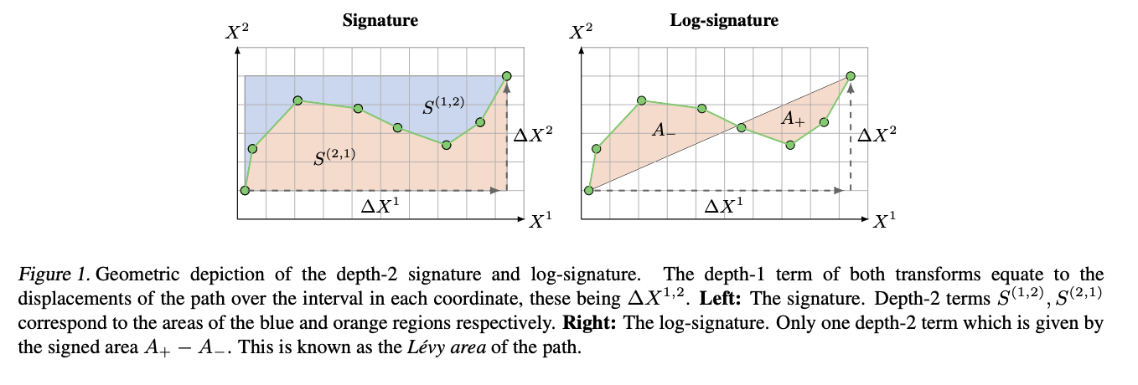

The depth-1 terms, S(x) (i) , equate to the displacement of the path over the interval in the ith coordinate, denoted by ∆Xi in Figure 1. The depth-2 terms, S(x) (i,j) , have interpretations in areas generated over the interval.

To get finer-scale information, we consider three other types of windows:

* sliding,
* expanding and
* hierarchical dyadic windows.

The expanding window produces time series of increasing length and is analogous to the history processes of stochastic analysis whereas the sliding window produces time series of fixed length but shifted in time.

Finally, we consider a hierarchical dyadic window, which captures information at different scales. Let q ∈ N be fixed and assume for simplicity that 2 q−1 divides n. Then, the hierarchical dyadic window of depth q consists of q sliding windows W1 , . . . , Wq , where Wi has length and step both equal to n2 −(i−1).